Game Starts with index.html  
  
<div class="chess-table">

        <table class="mychesstable w3-container w3-center w3-animate-zoom">

            <tr>

                <td>

        <div id="h8" class="piece-box black-box"></div>

    </td>

    <td> <div id="g8" class="piece-box white-box"></div>

    </td>

    <td>  <div id="f8" class="piece-box black-box"></div>

    </td>

    <td> <div id="e8" class="piece-box white-box"></div>

    </td>

    <td><div id="d8" class="piece-box black-box"></div>

    </td>

    <td>  <div id="c8" class="piece-box white-box"></div></td>

        <td>  <div id="b8" class="piece-box black-box"></div></td>

        <td>   <div id="a8" class="piece-box white-box"></div>

    </td>

</tr><tr>

        <td><div id="h7" class="piece-box white-box"></div></td>

        <td><div id="g7" class="piece-box black-box"></div></td>

        <td><div id="f7" class="piece-box white-box"></div></td>

        <td><div id="e7" class="piece-box black-box"></div></td>

        <td><div id="d7" class="piece-box white-box"></div></td>

        <td><div id="c7" class="piece-box black-box"></div></td>

        <td><div id="b7" class="piece-box white-box"></div></td>

        <td><div id="a7" class="piece-box black-box"></div></td>

    </tr><tr>

      <td> <div id="h6" class="piece-box black-box"></div></td>

      <td> <div id="g6" class="piece-box white-box"></div></td>

      <td> <div id="f6" class="piece-box black-box"></div></td>

      <td> <div id="e6" class="piece-box white-box"></div></td>

      <td> <div id="d6" class="piece-box black-box"></div></td>

      <td> <div id="c6" class="piece-box white-box"></div></td>

      <td> <div id="b6" class="piece-box black-box"></div></td>

      <td> <div id="a6" class="piece-box white-box"></div></td>

    </tr><tr>

         <td><div id="h5" class="piece-box white-box"></div></td>

         <td><div id="g5" class="piece-box black-box"></div></td>

         <td><div id="f5" class="piece-box white-box"></div></td>

         <td><div id="e5" class="piece-box black-box"></div></td>

         <td><div id="d5" class="piece-box white-box"></div></td>

         <td><div id="c5" class="piece-box black-box"></div></td>

         <td><div id="b5" class="piece-box white-box"></div></td>

         <td><div id="a5" class="piece-box black-box"></div></td>

        </tr><tr>

         <td><div id="h4" class="piece-box black-box"></div></td>

         <td><div id="g4" class="piece-box white-box"></div></td>

         <td><div id="f4" class="piece-box black-box"></div></td>

         <td><div id="e4" class="piece-box white-box"></div></td>

         <td><div id="d4" class="piece-box black-box"></div></td>

         <td><div id="c4" class="piece-box white-box"></div></td>

         <td><div id="b4" class="piece-box black-box"></div></td>

         <td><div id="a4" class="piece-box white-box"></div></td>

        </tr><tr>

         <td><div id="h3" class="piece-box white-box"></div></td>

         <td><div id="g3" class="piece-box black-box"></div></td>

         <td><div id="f3" class="piece-box white-box"></div></td>

         <td><div id="e3" class="piece-box black-box"></div></td>

         <td><div id="d3" class="piece-box white-box"></div></td>

         <td><div id="c3" class="piece-box black-box"></div></td>

         <td><div id="b3" class="piece-box white-box"></div></td>

         <td><div id="a3" class="piece-box black-box"></div></td>

        </tr><tr>

         <td><div id="h2" class="piece-box black-box"></div></td>

         <td><div id="g2" class="piece-box white-box"></div></td>

         <td><div id="f2" class="piece-box black-box"></div></td>

         <td><div id="e2" class="piece-box white-box"></div></td>

         <td><div id="d2" class="piece-box black-box"></div></td>

         <td><div id="c2" class="piece-box white-box"></div></td>

         <td><div id="b2" class="piece-box black-box"></div></td>

         <td><div id="a2" class="piece-box white-box"></div></td>

</tr><tr>

         <td><div id="h1" class="piece-box white-box"></div></td>

         <td><div id="g1" class="piece-box black-box"></div></td>

         <td><div id="f1" class="piece-box white-box"></div></td>

         <td><div id="e1" class="piece-box black-box"></div></td>

         <td><div id="d1" class="piece-box white-box"></div></td>

         <td><div id="c1" class="piece-box black-box"></div></td>

         <td><div id="b1" class="piece-box white-box"></div></td>

         <td><div id="a1" class="piece-box black-box"></div></td>

</tr>

</table>

    </div>

<!--Chess Table-->

Three listeners are added per piece  
  
 this.piecesEventListeners[ pieceBoxPosition ] = {

                'mouseenter': _ => {

                   // alert("Mouse Enter")

                    piecesHandle.handlePieceMouseenter( handleParams )

                    //Mouse enter. Highlight the position in yellow is done by css

                },

                'mouseleave': _ => {

                    piecesHandle.handlePieceMouseleave( handleParams )

                    //Remove highlighting

                },

                'click': _ => {

                    piecesHandle.handlePieceClick( handleParams )

                    //Highlight possible move positions

                },

            }

            pieceBoxElement.addEventListener( 'mouseenter', this.piecesEventListeners[ pieceBoxPosition ][ 'mouseenter' ])

            pieceBoxElement.addEventListener( 'mouseleave', this.piecesEventListeners[ pieceBoxPosition ][ 'mouseleave' ])

            pieceBoxElement.addEventListener( 'click', this.piecesEventListeners[ pieceBoxPosition ][ 'click' ])

1. Next app.js is loaded. App.js is at [](app.js)

App.js loads './services/piecesRender.service.js'

[](services/piecesRender.service.js)

Then RenderPieces function is called. This function loads a gamesetup from const gameSetup = chessConfig.useInitialGame ? initialGame : potentialGame/

chessConfig initialGame and potential game are in the config folder

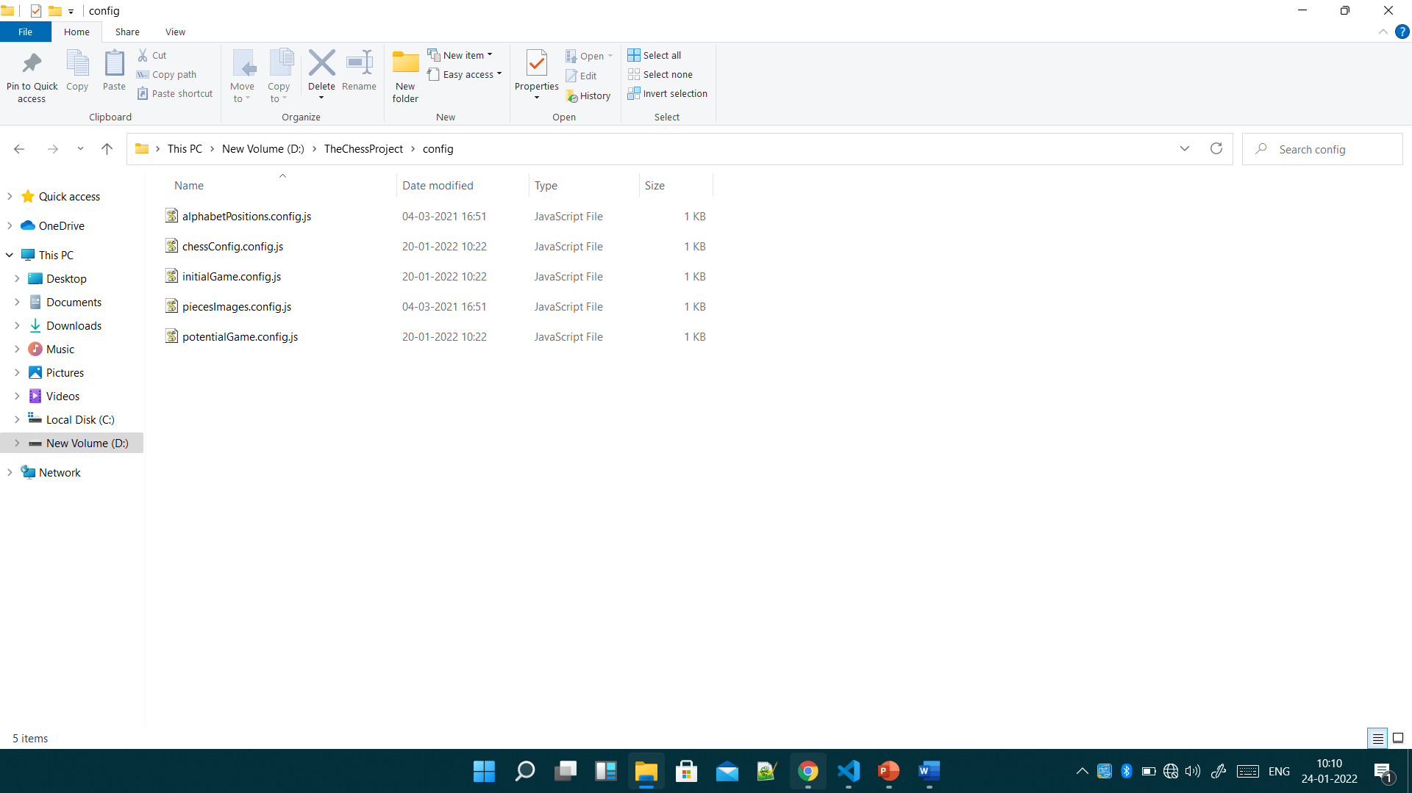

This is the initialGame.js file

export const initialGame = {

    'a8': 'black_rook',

    'b8': 'black_knight',

    'c8': 'black_bishop',

    'd8': 'black_queen',

    'e8': 'black_king',

    'f8': 'black_bishop',

    'g8': 'black_knight',

    'h8': 'black_rook',

    'a7': 'black_pawn',

    'b7': 'black_pawn',

    'c7': 'black_pawn',

    'd7': 'black_pawn',

    'e7': 'black_pawn',

    'f7': 'black_pawn',

    'g7': 'black_pawn',

    'h7': 'black_pawn',

    'a1': 'white_rook',

    'b1': 'white_knight',

    'c1': 'white_bishop',

    'd1': 'white_queen',

    'e1': 'white_king',

    'f1': 'white_bishop',

    'g1': 'white_knight',

    'h1': 'white_rook',

    'a2': 'white_pawn',

    'b2': 'white_pawn',

    'c2': 'white_pawn',

    'd2': 'white_pawn',

    'e2': 'white_pawn',

    'f2': 'white_pawn',

    'g2': 'white_pawn',

    'h2': 'white_pawn',

}

Next placepiecesinposition in the same piecesrenderfile  
placePiecesInPosition